Ennis Regional Hospital



***MyHealthPoint Patient Portal***

<https://ennisregional.myhealthpoint.lpnt.net/>

Accessing your Personal Health Information

**MY LOGIN INFORMATION: Must have active email or smart phone number setup within the Ennis Regional Medical Center computer system**

EMAIL PASSWORD

What is MyHealthPoint?

The MyHealthPoint Patient Portal website makes accessing your personal health information easy, secure, and convenient way for you to access your health records. With MyHealthPoint Patient Portal, you can view your health information at any time from any location with an internet connection including computers, tables, and smartphones.

How do I get started?

2 Easy Ways to Enroll:

Enroll at registration by informing them you want to participate in the Patient Portal and provide an email or smart phone number. If you enroll using a smart phone number, your notices will come via SMA messages instead of emails. **To complete your MyHealthPoint registration, you will need to verify your identity by following a link that will be emailed/SMS message to you. Once you receive the email/SMS message, click the link to be directed to the Sign in page. If you haven’t done so already, you will be prompted to verify demographic information, set a password, and select a security question.

Signing in AFTER you have already set a password:

1. Go to <https://ennisregional.myhealthpoint.lpnt.net/>
2. Type in your email address.
3. Type in your password. (Passwords are case sensitive)
4. Click on “Submit”. The Home Page (Shown on Page 2) will display.

NOTE: If this is your first time signing in, you will be prompted to read and agree to MyHealthPoint terms of use before proceeding.

**If you forget your password:

1. Click “Forgot Password”
2. Type your email address in the Email field.
3. Click “Get New Password”. A new page will display and direct you to your email for further directions.

AN EMAIL ADDRESS CAN ONLY BE USED FOR 1 (ONE) PATIENT PORTAL ACCOUNT. YOU CANNOT USE THE SAME EMAIL ADDRESS FOR MULTIPLE PATIENT PORTAL ACCOUNTS.

How do I navigate MyHealthPoint?

After you sign in, the Home page (shown below) will display.

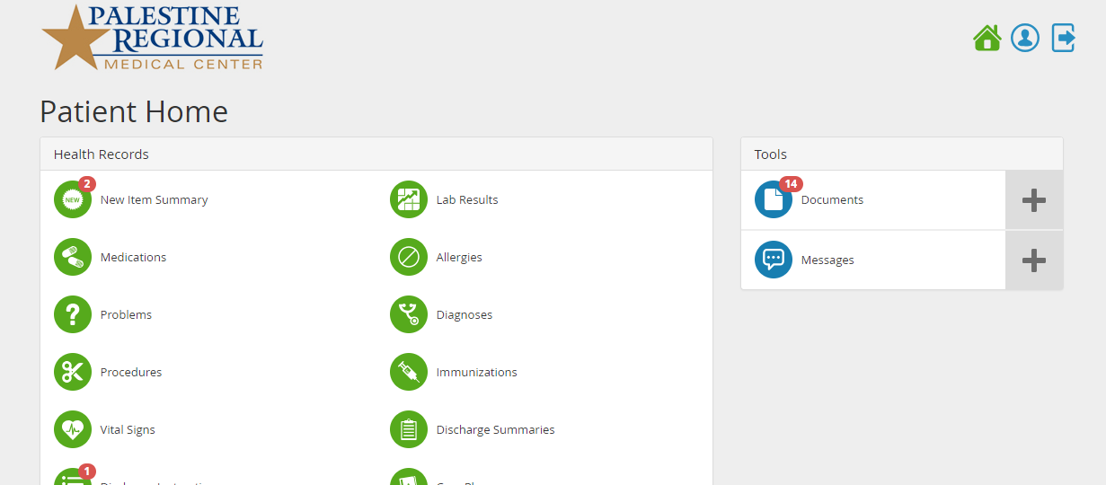

How do I manage documents?

You can view, email, download, archive, delete, and upload documents.

NOTE: Archiving a document hides the document by moving it to an archive so that it is no longer viewable in its regular list. Archived documents can be unhidden.

Deleting the document is permanent and cannot be undone.

To View a document:

1. From the Patient Dashboard click on “Documents” to the right of the screen. The Documents page will display.

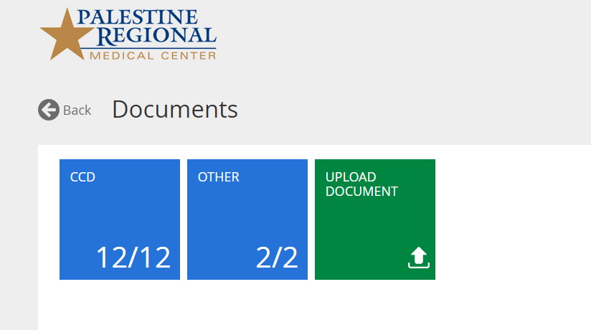

1. Click the “CCD” tile. A list of available documents will display.
2. Click the document you want to view. The selected document will display. 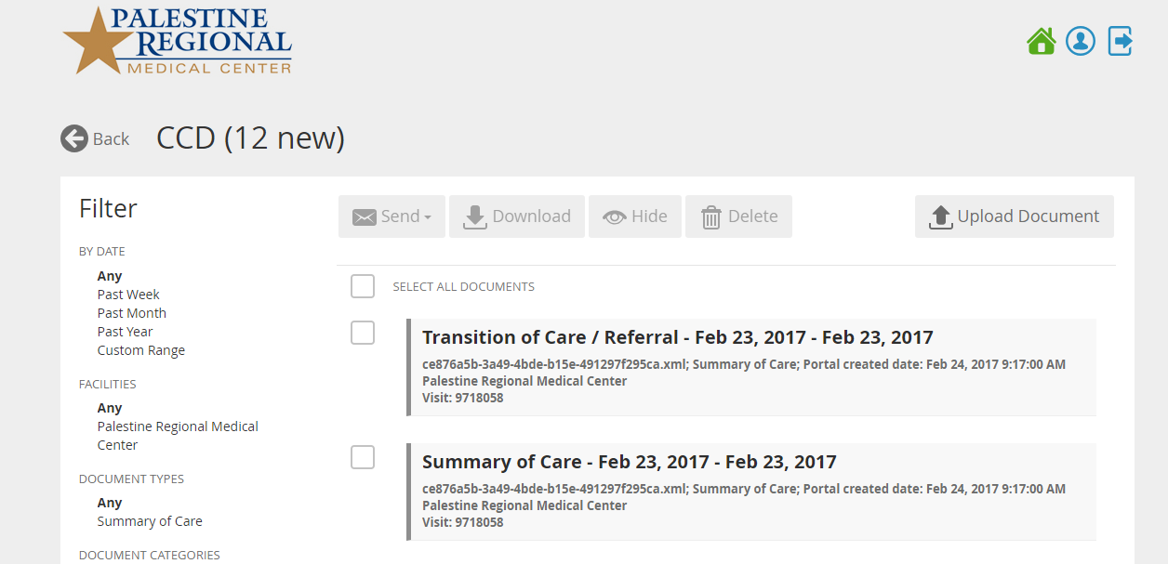
3. Click on the document to open. From there you will be able to view, email, download, or delete your document.

To download a document to your computer:

1. Find the document you want to download by following steps 1 and 2 of “To view a document” (above)
2. Select the check box to the left of the document you want to download.

NOTE: More than one document can be selected.

1. Click “Download”.
2. Follow your computer’s prompts to select a download location on your computer.

**To Hide a document:

1. Find the document you want to Hide.
2. Select the check box to the left of the document.
3. Click “Hide”

To Unhide a document:

1. From the Documents page Click the Hidden tile. A list of hidden documents will appear.
2. Select the check box to the left of the document you want to Unhide.
3. Click “Unhide”. The document will be moved to the location it was originally archived from.

How do I get more HELP?

Questions on how to use the site?

The help system provides detailed instructions on using the site. To open, click Help from the toolbar at the bottom right of the window. 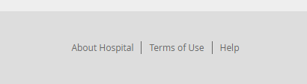.

The Help page will display and show information related to the current page. To find other help topics, type keywords in the Search box and then click the Search icon. **

MORE QUESTION: Please use the contact information below.

Joanna Rios, RN

Clinical Informatics / MyHealthPoint Representative

**Joanna.rios@scionhealth.com**

**Phone# - 469-256-2448 ext 2448**